Name:- Document-3
Solution:-

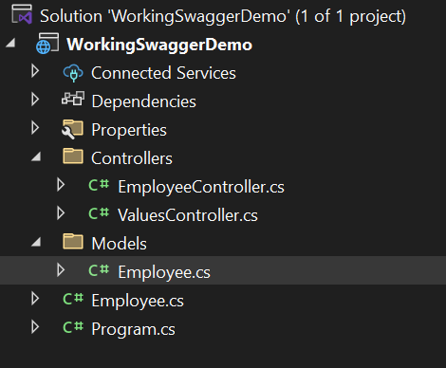

Code for Employee.cs in Models

using System;
using System.Collections.Generic;

namespace WorkingSwaggerDemo.Models
{
public class Employee
{
public int Id { get; set; }
public string Name { get; set; } = "";
public int Salary { get; set; }
public bool Permanent { get; set; }
public Department Department { get; set; } = new();
public List<Skill> Skills { get; set; } = new();
public DateTime DateOfBirth { get; set; }
}

public class Department
{
public int Id { get; set; }
public string Name { get; set; } = "";
}
public class Skill
{
public int Id { get; set; }
public string Name { get; set; } = "";
}
}

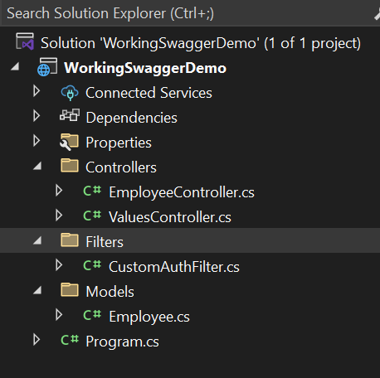

Code for CustomAuthFilter.cs in Filters

using Microsoft.AspNetCore.Mvc;
using Microsoft.AspNetCore.Mvc.Filters;

namespace WorkingSwaggerDemo.Filters
{
public class CustomAuthFilter : ActionFilterAttribute
{
public override void OnActionExecuting(ActionExecutingContext context)
{
if (!context.HttpContext.Request.Headers.TryGetValue("Authorization", out var token))
{
context.Result = new BadRequestObjectResult("Invalid request - No Auth token");
return;
}

if (!token.ToString().Contains("Bearer"))
{
context.Result = new BadRequestObjectResult("Invalid request - Token present but Bearer unavailable");
}
}
}
}

Updated Code For EmployeeController.cs in Controllers

using Microsoft.AspNetCore.Authorization;
using Microsoft.AspNetCore.Mvc;
using WorkingSwaggerDemo.Filters;
using WorkingSwaggerDemo.Models;

namespace WorkingSwaggerDemo.Controllers
{
[ApiController]
[Route("api/Emp")]
[ServiceFilter(typeof(CustomAuthFilter))]
public class EmployeeController : ControllerBase
{
private List<Employee> _employees;

public EmployeeController()
{
_employees = GetStandardEmployeeList();
}

private List<Employee> GetStandardEmployeeList()
{
return new List<Employee>
{
new Employee
{
Id = 1,
Name = "GAUTAM KUMAR",
Salary = 50000,
Permanent = true,
DateOfBirth = new DateTime(2003, 11, 5),
Department = new Department { Id = 101, Name = "IT" },
Skills = new List<Skill>
{
new Skill { Id = 1, Name = "C#" },
new Skill { Id = 2, Name = "ASP.NET Core" }
}
}
};
}
[HttpGet]
[AllowAnonymous]
[ProducesResponseType(StatusCodes.Status200OK)]
public ActionResult<List<Employee>> Get()
{
return Ok(_employees);
}

[HttpPost]
[ProducesResponseType(StatusCodes.Status200OK)]
public IActionResult Post([FromBody] Employee emp)
{
return Ok($"Employee added: {emp.Name}");
}
}
}

Updated Code for Program.cs

using Microsoft.OpenApi.Models;
using WorkingSwaggerDemo.Filters;

var builder = WebApplication.CreateBuilder(args);
builder.Services.AddControllers();
builder.Services.AddScoped<CustomAuthFilter>();

builder.Services.AddEndpointsApiExplorer();
builder.Services.AddSwaggerGen(c =>
{
c.SwaggerDoc("v1", new OpenApiInfo
{
Title = "Swagger Demo",
Version = "v1",
Description = "Custom WebAPI with Filters",
TermsOfService = new Uri("https://example.com/terms"),
Contact = new OpenApiContact
{
Name = "John Doe",
Email = "john@xyzmail.com",
Url = new Uri("https://www.example.com")
},
License = new OpenApiLicense
{
Name = "License Terms",
Url = new Uri("https://www.example.com")
}
});
});

var app = builder.Build();
app.UseSwagger();
app.UseSwaggerUI(c =>
{
c.SwaggerEndpoint("/swagger/v1/swagger.json", "Swagger Demo");
});

app.UseHttpsRedirection();
app.UseAuthorization();
app.MapControllers();
app.Run();

Test GET Request

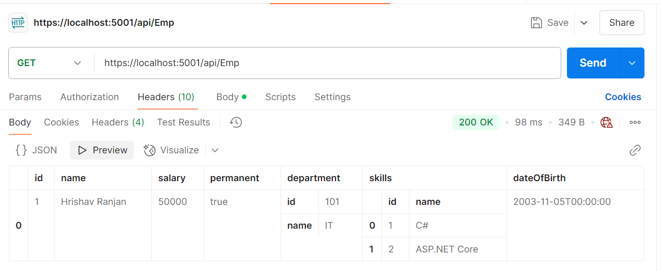

TEST POST REQUEST

{
"id": 2,
"name": "Mickey",
"salary": 45000,
"permanent": true,
"dateOfBirth": "2004-10-05T00:00:00",
"department": {
"id": 102,
"name": "HR"
},
"skills": [
{
"id": 1,
"name": "Java"
}
]
}

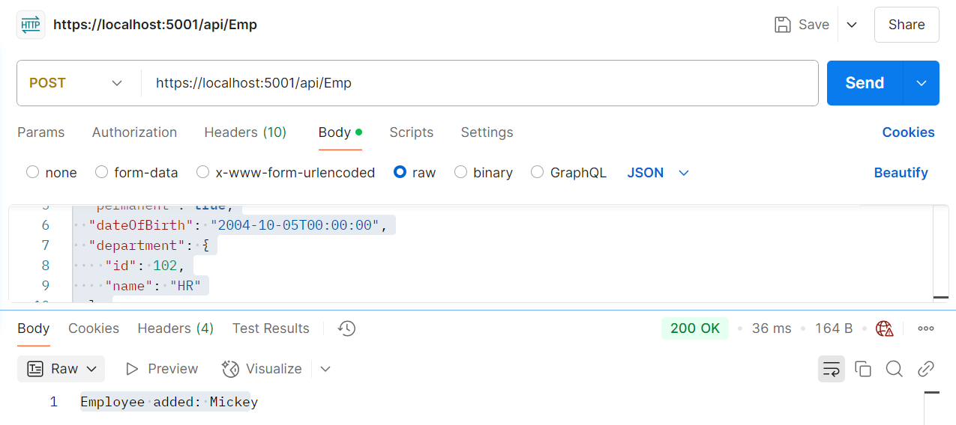

Create a Custom action filter for Authorization.Create CustomExceptionFilter.cs in Filters

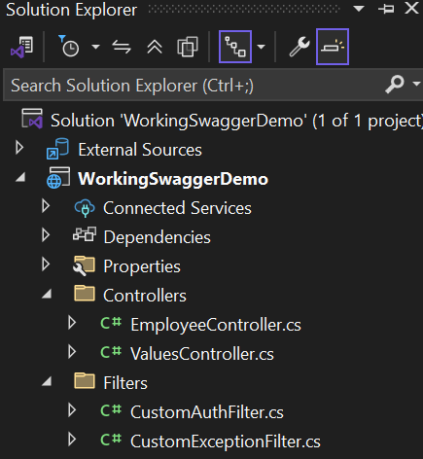

Code CustomExceptionFilter.cs in Filters

using Microsoft.AspNetCore.Mvc;
using Microsoft.AspNetCore.Mvc.Filters;
using System.IO;

namespace WorkingSwaggerDemo.Filters
{
public class CustomExceptionFilter : IExceptionFilter
{
public void OnException(ExceptionContext context)
{
var exception = context.Exception;
string logFilePath = "error_log.txt";
File.AppendAllText(logFilePath, $"[{DateTime.Now}] {exception.Message}\n");
context.Result = new ObjectResult("An internal error occurred.")
{
StatusCode = 500
};

context.ExceptionHandled = true;
}
}
}

Updated Code for Program.cs

using Microsoft.OpenApi.Models;
using WorkingSwaggerDemo.Filters;

var builder = WebApplication.CreateBuilder(args);

builder.Services.AddControllers();
builder.Services.AddScoped<CustomAuthFilter>();
builder.Services.AddScoped<CustomExceptionFilter>();

builder.Services.AddEndpointsApiExplorer();
builder.Services.AddSwaggerGen(c =>
{
c.SwaggerDoc("v1", new OpenApiInfo
{
Title = "Swagger Demo",
Version = "v1",
Description = "Custom WebAPI with Filters",
TermsOfService = new Uri("https://example.com/terms"),
Contact = new OpenApiContact
{
Name = "John Doe",
Email = "john@xyzmail.com",
Url = new Uri("https://www.example.com")
},
License = new OpenApiLicense
{
Name = "License Terms",
Url = new Uri("https://www.example.com")
}
});
});

var app = builder.Build();
app.UseSwagger();
app.UseSwaggerUI(c =>
{
c.SwaggerEndpoint("/swagger/v1/swagger.json", "Swagger Demo");
});

app.UseHttpsRedirection();
app.UseAuthorization();

app.MapControllers();
app.Run();

Updted Code for EmployeeController.cs

using Microsoft.AspNetCore.Authorization;
using Microsoft.AspNetCore.Mvc;
using WorkingSwaggerDemo.Filters;
using WorkingSwaggerDemo.Models;

namespace WorkingSwaggerDemo.Controllers
{
[ApiController]
[Route("api/Emp")]
[ServiceFilter(typeof(CustomAuthFilter))]
[ServiceFilter(typeof(CustomExceptionFilter))]
public class EmployeeController : ControllerBase
{
private List<Employee> _employees;

public EmployeeController()
{
_employees = GetStandardEmployeeList();
}

private List<Employee> GetStandardEmployeeList()
{
return new List<Employee>
{
new Employee
{
Id = 1,
Name = "GAUTAM KUMAR",
Salary = 50000,
Permanent = true,
DateOfBirth = new DateTime(2003, 11, 5),
Department = new Department { Id = 101, Name = "IT" },
Skills = new List<Skill>
{
new Skill { Id = 1, Name = "C#" },
new Skill { Id = 2, Name = "ASP.NET Core" }
}
}
};
}
[HttpGet]
[AllowAnonymous]
[ProducesResponseType(StatusCodes.Status200OK)]
[ProducesResponseType(StatusCodes.Status500InternalServerError)]
public ActionResult<List<Employee>> Get()
{

throw new Exception("This is a test exception from GET.");

}
[HttpPost]
[ProducesResponseType(StatusCodes.Status200OK)]
[ProducesResponseType(StatusCodes.Status400BadRequest)]
public IActionResult Post([FromBody] Employee emp)
{
if (emp == null || string.IsNullOrEmpty(emp.Name))
{
return BadRequest("Invalid Employee data");
}

return Ok($"Employee added: {emp.Name}");
}
}
}

